# Project Title: ‘ …. ‘

### **Team members**

|  |  |  |  |
| --- | --- | --- | --- |
| Clint Rogers | Yongsuk Kang | Allie Seaman | Zahra Hosseinian |

### **Project Description:** We are going visualize use of and education of Long-Acting Reversible Contraceptives (LARCs) in women

### **Dataset(s):**

* [Illinois Perinatal Quality Collaborative](https://ilpqc.org/)
  + REDCap Survey Data will be exported by Zahra

### **Roles:**

* Project Manager – Zahra
* Back End -- Henry
* Flask -- Clint
* Front End – Allie

### **GitHub Repository:**

### <https://github.com/zhosseinian/project-two>

### **Breakdown of Tasks:**

|  |  |  |  |  |
| --- | --- | --- | --- | --- |
| **Team Member** | Clint Rogers | Yongsuk Kang | Allie Seaman | Zahra Hosseinian |
| Git Master |  |  |  | X |
| **Tasks** |  |  |  |  |
| Project Ideas | X | X | X | X |
| Dataset |  |  |  | X |
| Project Proposal |  |  |  | X |
| Powerpoint | X | X | X | X |
| Data cleanup | X | X | X | X |
| GitHub cleanup |  | X | X |  |
| Visualizations | X | X | X | X |
| Dashboard | X | X | X | X |

### **Metadata Screenshot:**

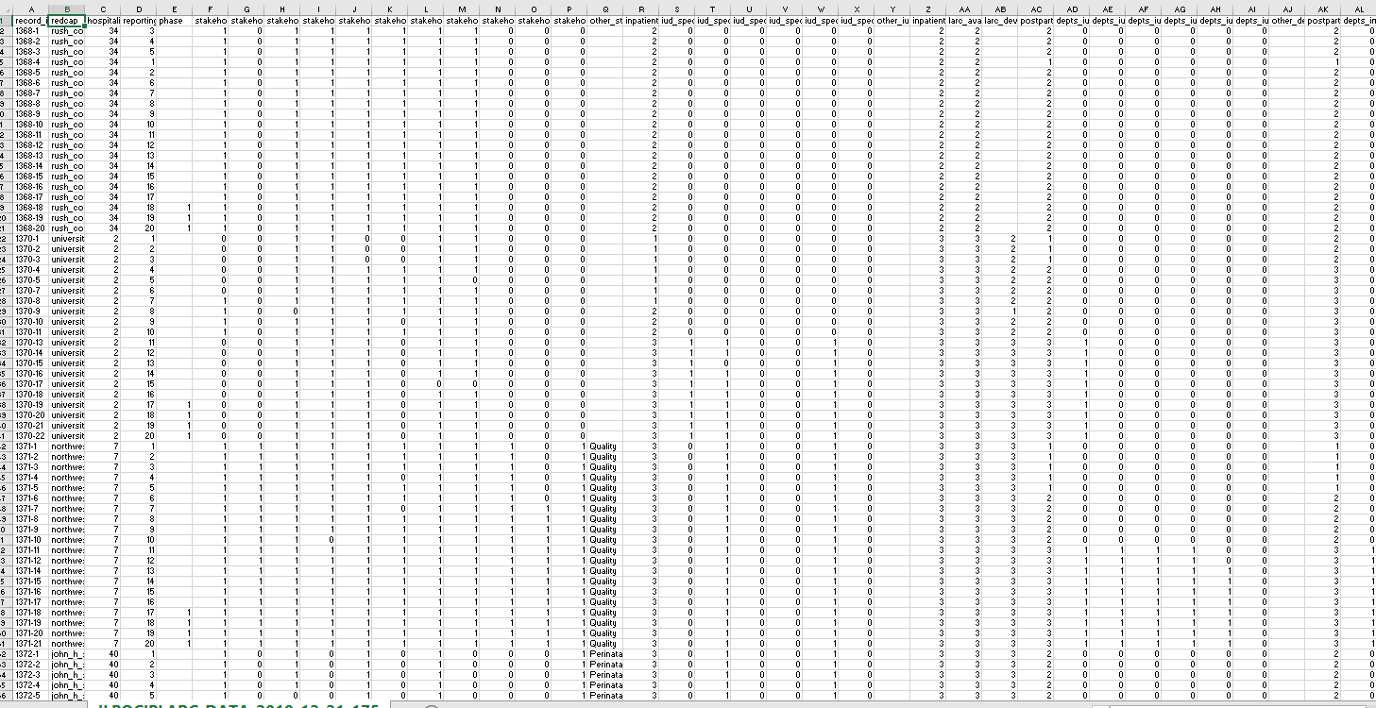

### **Screenshots of potential interest -- visualizations:**



 